# City of Fall River

**Massachusetts**

Police Department

Daniel S. Racine

Chief of Police

Public Information Office

685 Pleasant Street

Fall River, Massachusetts 02721

(508) 676-8511 Ext. 210 and 272

**Lt. Ronald Furtado**

**Lt. Paul Santos**

**PRESS RELEASE**

For Immediate Release-Fall River, Massachusetts October 2, 2017

Police Spokesman- Lieutenant Paul Santos

The Fall River Police Department would like to thank the public for their assistance in capturing several of the individuals listed on the previous Top 10 Most Wanted List.

The Fall River Police Department is once again asking the public’s assistance in locating the following individuals from the updated Fall River Police Department’s Top 10 Most Wanted List.

Anyone with information on the following individuals is urged to contact the Fall River Police Special Operations Division (508)324-2801 or the Fall River Police Main Line [(508)676-8511](callto:(508)676-8511).

Community Members wishing to assist anonymously can do so by calling the Anonymous TIPS Line (508)672-TIPS. The Fall River Police Department will stringently guard and protect the identities of all those who wish to help in an anonymous manner.

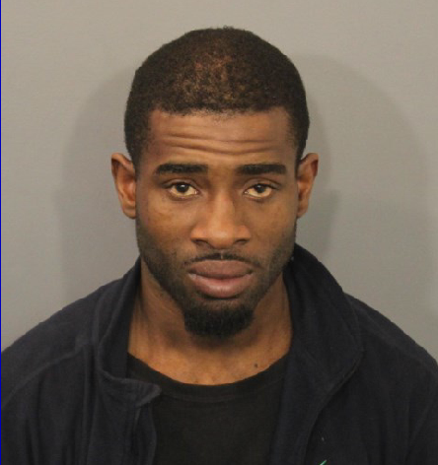

**Meshach Ricks**

LKA. 219 Purchase Street, Fall River, MA.

Age: 31

Sex: M

Race: B

Ethnicity: Non- Hispanic

Height: 5’9”-5’10”

Weight: 150-180

Eyes: Brown

Hair: Black

Count Offense Code Description

1 F 265/13M/B A&B ON FAMILY / HOUSEHOLD MEMBER c265 S13M(a)

1 F 265/13A/E A&B, PREGNANT VICTIM c265 S13A(b)

1 M+ 90/23/E LICENSE SUSPENDED, OP MV WITH, SUBSQ.OFF. c90 S

1 M- 270/16/E TRASH, LITTER FROM MV c270 S16

1 M+ 94C/32C/D DRUG, POSSESS TO DISTRIB CLASS D, SUBSQ. c94C S

1 M+ 90/23/C LICENSE REVOKED AS HTO, OPERATE MV WITH c90 S23

1 M+ 90/23/C LICENSE REVOKED AS HTO, OPERATE MV WITH c90 S23

1 M- 90/23/D LICENSE SUSPENDED, OP MV WITH c90 S23

1 CM 90/17/A SPEEDING * c90 S17



**Keenan Ritter**

LKA. 158 Fourth Street, Apt. #5, Fall River, MA.

Age: 25

Sex: M

Race: B

Ethnicity: Non- Hispanic

Height: 5’11”

Weight: 210

Eyes: Brown

Hair: Black

Count Offense Code Description

1 F 265/13M/B A&B ON FAMILY / HOUSEHOLD MEMBER c265 S13M(a)

1 F 268/13B/A WITNESS/JUROR/POLICE/COURT OFFICIAL, INTIMIDATE

1 F 265/15A/A A&B WITH DANGEROUS WEAPON c265 S15A(b)

1 F 265/15D/A STRANGULATION OR SUFFOCATION c265 S15D(b)

1 F 268/13B/A WITNESS/JUROR/POLICE/COURT OFFICIAL, INTIMIDATE

1 F 265/13M/B A&B ON FAMILY / HOUSEHOLD MEMBER c265 S13M(a)

1 F 265/15B/A ASSAULT W/DANGEROUS WEAPON c265 S15B(b)

1 M+ 94C/34/A DRUG, POSSESS CLASS A c94C S34

1 F 94C/32A/G DRUG, POSSESS TO DISTRIB CLASS B c94C S32A(a)

1 F 94C/32A/G DRUG, POSSESS TO DISTRIB CLASS B c94C S32A(a)

1 F 94C/32/C DRUG, POSSESS TO DISTRIB CLASS A c94C S32(a)

1 F 94C/32/C DRUG, POSSESS TO DISTRIB CLASS A c94C S32(a)

1 F 94C/32/D DRUG, POSSESS TO DISTRIB CLASS A, SUBSQ.

1 F 94C/32A/C COCAINE, POSSESS TO DISTRIBUTE c94C S32A(c)

1 F 94C/32A/D COCAINE, POSSESS TO DISTRIBUTE, SUBSQ.

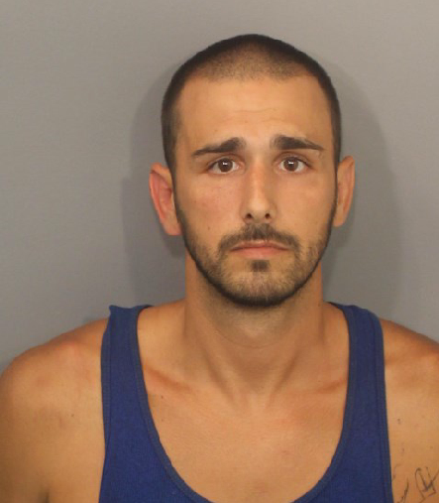

**Jonathan Pimental**

LKA. 305 Hamlet Street, Fall River, MA.

Age: 32

Sex: M

Race: W

Ethnicity: Non- Hispanic

Height: 5’10”

Weight: 160

Eyes: Brown

Hair: Brown

Count Offense Code Description

1 F 6/178H/B SEX OFFENDER FAIL TO REGISTER, SUBSQ.OFF. c6 S1

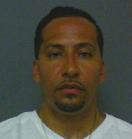

**Michael A. Viruet**

LKA. 672 Tucker St. Fall River, MA.

Age: 40

Sex: M

Race: B

Ethnicity: Non- Hispanic

Height: 6’

Weight: 150

Eyes: Brown

Hair: Brown

Count Offense Code Description

1 F 268/13B/A WITNESS/JUROR/POLICE/COURT OFFICIAL, INTIMIDATE

1 M+ 275/2 THREAT TO COMMIT CRIME c275 S2

1 M+ 90/34J UNINSURED MOTOR VEHICLE c90 S34J

1 CM 90/9/B UNREGISTERED MOTOR VEHICLE * c90 S9

1 F 265/18C/A HOME INVASION c265 S18C

1 F 265/15B/A ASSAULT W/DANGEROUS WEAPON c265 S15B(b)

1 F 266/20/A LARCENY FROM BUILDING c266 S20

1 F 266/17/A ENTER AT NIGHT FOR FELONY,PERSON IN FEAR c266 S1

1 F 265/26/A KIDNAPPING c265 S26

1 F 265/18C/A HOME INVASION c265 S18C

1 F 265/18/C ASSAULT TO MURDER, ARMED c265 S18(b)

1 F 265/17/B ROBBERY, ARMED & MASKED c265 S17

1 F 266/14/C BURGLARY, ARMED & ASSAULT c266 S14



**Christopher Lane II**

LKA. 69 Techumseh St. Fall River, MA.

Age: 20

Sex: M

Race: B

Ethnicity: Non- Hispanic

Height: 5’2”

Weight: 110

Eyes: Brown

Hair: Black

Count Offense Code Description

1 F 265/18/J ASSAULT TO MURDER, FIREARM-ARMED c265 S18(b)

1 M- 269/12E FIREARM, DISCHARGE WITHIN 500 FT OF BLDG c269 S

1 F 269/10/EE FIREARM WITHOUT LICENSE, CARRY LOADED c269 S10(

1 F 265/15F A&B WITH FIREARM c265 S15F

1 F 269/10/J FIREARM, CARRY WITHOUT LICENSE c269 S10(a)



**Jarad Anderson**

LKA. 564 Plymouth Ave. Fall River, MA.

Age: 19

Sex: M

Race: B

Ethnicity: Non- Hispanic

Height: 5’09”

Weight: 200

Eyes: Brown

Hair: Black

Count Offense Code Description

1 F 265/26/A KIDNAPPING c265 S26

1 F 265/26/A KIDNAPPING c265 S26

1 F 268/13B/A WITNESS/JUROR/POLICE/COURT OFFICIAL, INTIMIDATE

1 M- 266/120 TRESPASS c266 S120

1 F 269/10/EE FIREARM WITHOUT LICENSE, CARRY LOADED c269 S10

1 F 265/15F A&B WITH FIREARM c265 S15F

1 M- 269/12E FIREARM, DISCHARGE WITHIN 500 FT OF BLDG

1 F 269/10/J FIREARM, CARRY WITHOUT LICENSE c269 S10(a)



**Tha Boun**

LKA. 108 Grant St. Apt. #2N, Fall River, Ma

Age: 36

Sex: M

Race: A

Ethnicity: Non- Hispanic

Height: 5’10”

Weight: 215

Eyes: Brown

Hair: Black

Count Offense Code Description

1 F 269/10/J FIREARM, CARRY WITHOUT LICENSE

1 F 269/10/EE FIREARM WITHOUT LICENSE, CARRY LOADED

1 M- 269/12E FIREARM, DISCHARGE WITHIN 500 FT OF BLDG



**Mark Cleaves**

LKA. 124 Bowen St. Fall River, MA

Age: 46

Sex: M

Race: B

Ethnicity: Non-Hispanic

Height: 6’2”

Weight: 280

Eyes: Brown

Hair: Black

Count Offense Code Description

1 F 265/13K/F A&B ON +60/DISABLED c265 S13K(a 1/2)

1 F 266/126A VANDALIZE PROPERTY c266 S126A

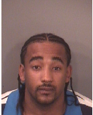

**Dale Alexander Davis**

LKA. 73 Emmett St. Fall River, MA

Age: 37

Sex: M

Race: B

Ethnicity: Non-Hispanic

Height: 5’11”

Weight: 200

Eyes: Brown

Hair: Black

Count Offense Code Description

1 F 94C/32A/G DRUG, POSSESS TO DISTRIB CLASS B c94C S32A(a)

1 F 94C/32J DRUG VIOLATION NEAR SCHOOL/PARK c94C S32J

1 F 94C/32E/A COCAINE, TRAFFICKING IN, 18 GRAMS OR MORE, LESS

1 F 94C/32J DRUG VIOLATION NEAR SCHOOL/PARK c94C S32J

1 M+ 94C/34/G DRUG, POSSESS CLASS D c94C S34



**Kenyatta N. Lumpkin**

LKA. 2235 South Main St. Apt.#2, Fall River, MA

Age: 42

Sex: M

Race: B

Ethnicity: Non-Hispanic

Height: 6’4”

Weight: 230

Eyes: Brown

Hair: Black

**C**ount Offense Code Description

1 F 6/178H/A SEX OFFENDER FAIL TO REGISTER c6 S178H(a)(1)

1 F 94C/37 DRUG, LARCENY OF c94C S37

1 M+ 275/2 THREAT TO COMMIT CRIME c275 S2

1 F 265/26/A KIDNAPPING c265 S26

1 F 268/13B/A WITNESS/JUROR/POLICE/COURT OFFICIAL, INTIMIDATE

1 F 265/15B/A ASSAULT W/DANGEROUS WEAPON c265 S15B(b)

1 F 266/25/A LARCENY FROM PERSON c266 S25(b)

1 M+ 275/2 THREAT TO COMMIT CRIME c275 S2

1 M+ 275/2 THREAT TO COMMIT CRIME c275 S2

1 M+ 94C/34/C DRUG, POSSESS CLASS B c94C S34

1 F 94C/32A/G DRUG, POSSESS TO DISTRIB CLASS B c94C S32A(a)

1 F 266/28/B MOTOR VEH, LARCENY OF c266 S28(a)

1 M- 90/23/D LICENSE SUSPENDED, OP MV WITH c90 S23

1 M+ 94C/34/C DRUG, POSSESS CLASS B c94C S34

1 M+ 275/2 THREAT TO COMMIT CRIME c275 S2